  

**AUTOMATIC WORKING WINDOW**

#### **A MINOR PROJECT-** **I REPORT**

**submitted by**

|  |  |
| --- | --- |
| **SHOBIKA S** | **927621BEC198** |
| **SOBIYA T** | **927621BEC205** |
| **SUJITHA V** | **927621BEC222** |
|  |  |

### **BACHELOR OF ENGINEERING**

in

**DEPARTMENT OF ELECTRONICS AND COMMUNICATION**

**ENGINEERING**

**M.KUMARASAMY COLLEGE OF ENGINEERING**

(Autonomous)

### **KARUR – 639 113**

**DECEMBER 2022**

**M.KUMARASAMY COLLEGE OF ENGINEERING**

**KARUR**

**BONAFIDE CERTIFICATE**

##### Certified that this project report **“AUTOMATIC WORKING WINDOW” is the bonafide work of “S. SHOBIKA (21BEC198), T. SOBIYA (21BEC205), V. SUJITHA (21BEC222)” who carried out the project work under my supervision in the academic year 2022-2023.**

|  |  |
| --- | --- |
| **SIGNATURE**  Dr.S. PALANIVELRAJAN, M.E., Ph.D.,  **HEAD OF THE DEPARTMENT,**  Professor,  Department of Electronics and  Communication Engineering,  M.Kumarasamy College of Engineering,  Thalavapalayam, Karur-639113. | **SIGNATURE**  Mrs. P. SAKTHI**,** M.E.,  **SUPERVISOR**  Assistant Professor,  Department of Electrical and  Electronics Engineering,  M.Kumarasamy College of Engineering,  Thalavapalayam, Karur-639113 |

This Minor project-I report has been submitted for the **18ECP103L – Minor Project-I**

Review held at M. Kumarasamy College of Engineering, Karur on ___2022-2023___.

**PROJECT COORDINATOR**

**Vision of the Institution**

To emerge as a leader among the top institutions in the field of technical education

#### **Mission of the Institution**

**M1:** Produce smart technocrats with empirical knowledge who can surmount the global challenges

**M2:** Create a diverse, fully engaged, learner-centric campus environment to provide quality education to the students

**M3:** Maintain mutually beneficial partnerships with our alumni, industry, and Professional associations Vision of the Department

#### **Vision of the Department**

To empower the Electronics and Communication Engineering students with emerging technologies, professionalism, innovative research, and social responsibility.

#### **Mission of the Department**

**M1:** Attain the academic excellence through innovative teaching learning process, research areas & laboratories and Consultancy projects.

**M2:** Inculcate the students in problem solving and lifelong learning ability.

**M3:** Provide entrepreneurial skills and leadership qualities.

**M4:** Render the technical knowledge and skills of faculty members.

#### **Program Educational Objectives (PEOs):**

**PEO1: Core Competence:** Graduates will have a successful career in academia or industry associated with Electronics and Communication Engineering.

**PEO2: Professionalism:** Graduates will provide feasible solutions for the challenging problems through comprehensive research and innovation in the allied areas of Electronics and Communication Engineering.

**PEO3: Lifelong Learning:** Graduates will contribute to the social needs through lifelong learning, practicing professional ethics and leadership quality

**Program Outcomes (POs):**

**PO 1: Engineering knowledge:** Apply the knowledge of mathematics, science, engineering fundamentals, and an engineering specialization to the solution of complex engineering problems.

**PO 2: Problem analysis:** Identify, formulate, review research literature, and analyze complex engineering problems reaching substantiated conclusions using first principles of mathematics, natural sciences, and engineering sciences.

**PO 3: Design/development of solutions:** Design solutions for complex engineering problems and design system components or processes that meet the specified needs with appropriate consideration for the public health and safety, and the cultural, societal, and environmental considerations.

**PO 4: Conduct investigations of complex problems:** Use research-based knowledge and research methods including design of experiments, analysis and interpretation of data, and synthesis of the information to provide valid conclusions.

**PO 5: Modern tool usage:** Create, select, and apply appropriate techniques, resources, and modern engineering and IT tools including prediction and modeling to complex engineering activities with an understanding of the limitations.

**PO 6: The engineer and society:** Apply reasoning informed by the contextual knowledge to assess societal, health, safety, legal and cultural issues, and the consequent responsibilities relevant to the professional engineering practice.

**PO 7: Environment and sustainability:** Understand the impact of the professional engineering solutions in societal and environmental contexts, and demonstrate the knowledge of, and need for sustainable development.

**PO 8: Ethics:** Apply ethical principles and commit to professional ethics and responsibilities and norms of the engineering practice.

**PO 9: Individual and teamwork:** Function effectively as an individual, and as a member or leader in diverse teams, and in multidisciplinary settings.

**PO 10: Communication:** Communicate effectively on complex engineering activities with the engineering community and with society at large, such as, being able to comprehend and write effective reports and design documentation, make effective presentations, and give and receive clear instructions.

**PO 11: Project management and finance:** Demonstrate knowledge and understanding of the engineering and management principles and apply these to one’s own work, as a member and leader in a team, to manage projects and in multidisciplinary environments.

**PO 12: Life-long learning:** Recognize the need for and have the preparation and ability to engage in independent and life-long learning in the broadest context of technological change.

**Program Specific Outcomes (PSOs):**

**PSO1:** Applying knowledge in various areas, like Electronics, Communications, Signal processing, VLSI, Embedded systems etc., in the design and implementation of Engineering application.

**PSO2:** Able to solve complex problems in Electronics and Communication Engineering with analytical and managerial skills either independently or in team using latest hardware and software tools to fulfil the industrial expectations.

**MAPPING OF PROJECT WITH POs AND PSO**

|  |  |
| --- | --- |
| **Abstract** | **Matching with POs, PSOs** |
| Automatic  Window Working. | P01,PO2,PO3,PO4,PO5,PO8,PO11,PO12,  PSO1,PSO2 |

# ABSTRACT

In this project we designed an automatic window opening and closing system, which is sensor based one, the sensor detects rainfall and the Arduino based sensors have been utilized to automate window’s opening and closing. In this project, Arduino microcontroller is used to control two function components which are the rainfall sensor and the motor, to automatically close the windows. In order to protect the household interior during rainy season this device has been developed. We developed an automatic window opening and closing system using rain sensor, this system will help the human being, when the rainfall occurs it will sense the water by the rain sensor then it will automatically close the window. The sensor detects the rain and it send the signals to the circuit board (i.e.) this circuit is designed with two lines which are tracked with very short distance. When raindrop falls on this circuit, the track may become short circuit. It gives the signal to related circuit in order to respond to the rain fall, due to this the window’s will be closed with the help of rack and pinion setup and when rainfall stops the window’s will automatically open.

**TABLE OF CONTENTS**

|  |  |  |  |  |
| --- | --- | --- | --- | --- |
| **CHAPTER No.** | | **CONTENTS** | | **PAGE No.** |
|  | | VISION AND MISSION OF THE INSTITUTE AND DEPARTMENT | | iii |
|  | | POs, PSOs OF THE DEPARTMENT | | v |
|  | | MAPPING OF PROJECT WITH POs AND PSOs | | vi |
|  | | ABSTRACT | | ix |
|  | | LIST OF FIGURES | | xi |
|  | | LIST OF ABBREVIATION xii | | | |
|  | |  | |  |
| 1 | | **INTRODUCTION** | |  |
| 2        3  4  5 | | * 1. Introduction   2. Background   3. Objectives   4. Literature Review   **HARDWARE DISCRIPTION**  2.1 Arduino UNO  2.2 Relay  2.3 Servo Motor  2.4 Rain Sensor  **RESULT**  **CONCLUSION**  **REFERENCEs** | | 13  15  16  17  19  21  22  23  26  28  29 |
|  | **LIST OF FIGURES** | |  | |
| **Figure No** | **Figure Name** | | **Page No** | |
| 1.1 | Pin Diagram | | 18 | |
| 2.1 | Arduino UNO | | 20 | |
| 2.2 | Relay | | 21 | |
| 2.3 | Servo Motor | | 22 | |
| 2.4 | Rain Drop Sensor Module | | 23 | |

|  |  |
| --- | --- |
|  | **LIST OF ABBREVIATION** |
| **IDE** | Integrated Development Environment |
| **USB** | Universal Serial Bus |
| **PWM** | Pulse Width Modulation |
| **AC** | Alternating Current |
| **DC** | Direct current |

**CHAPTER 1**

**1.1 INTRODUCTION**

The techniques of manually opening and closing windows have been practiced for centuries. This method involves some problems like rain water entering to the house etc.. Our endeavor is to create an automated window system which would shut itself automatically once a rain drop is sensed. This system should have a high efficiency because the target is to close the window at the very beginning of a drizzle. There are many important criteria to consider and one of those is durability. Usually customers expect a long-lasting product because they don't want to run around searching for repairing men and various equipment parts, so the life span of this product should be at least 10-15 years. To make this target possible methods should be introduced to minimize wearing out due to friction and replacement of parts like the motor. The product should be user friendly, attractive and cost efficient. The window system should not have an impact on the beauty of the house and it should have a decent appearance. In normal sunny days, people always leave the house window open for air circulation or allowing the sun rays. In case if we forget the house windows opened or we leave it because we do not expect rain might be fall, rain will fall inside the house. In many countries the amount of the rain is too much and it might destroy the whole house, if we forget or if we leave it open for the purposes, water damage irrespective of the source always causes devastating and the blow is really hard especially for the people whose houses are located rainy areas. When the water flows inside the house, it begins the trouble time. The rain water runs through every personal belonging which cause a financial loss. We want to figure a device that will save this mistake. A lot of people do not think that when rain fall a damage will happens to their houses. But when it happens, they will say in repeatedly I wish I closed window or I wish I install some devices that can close the windows automatically. The hardware that fits onto the window which pushes and pulls the window open and closed instead of operating the window manually. When the rain comes, we suddenly run to closed the windows. We think install some devices that can close window automatically. So, this report explains about all the technical methods and solutions about the automatic window.

**1.2 BACKGROUND**

Our country is suffering from rain and flood frequently. Althoughsometimes we see the windows are open during the rain if the people are notpresent inside. The project Automatic window working with Arduino and Relayhas been successfully designed and tested. It protects the thinks inside the housewithout any damages, it reduces the manual work by these advancedtechnologies. The main aim of the project is Automatic window close and openwith rain sensor; this is to save thinks which is present inside the building. Wewant to use this kind of window instead of doing manual. So, it’s easy to makecost effectiveness. This automatic working window can be used in some othercases like car, bus, etc. The report presents a new and innovative approach forwindow working. It offers cost savings and lower maintenance and operationcost.

**1.3 OBJECTIVES**

In this project we used automatic window opening and closing system techniques when sensor detects rainfall, it can be found that the Arduino based sensors have been utilized for automatic window opening and closings and automated car window opening and closings systems. Arduino microcontroller used to control two function components which are the rainfall sensor and the motor to automatically close the windows. When sensor detects rainfall windows will close automatically. Windows will close automatically without external forces. Without wasting our time, it will close automatically within a span of time.

**1.4 LITERATURE REVIEW**

A literature review is a critical summary and analysis of the existing research on a particular topic. In the context of an automatic window opening and closing using rain sensor project, a literature review would involve researching and summarizing of previous works on the topic of automatic window opening and closing using rain sensors systems. Some of the project works that are done before related to this are:

Alaa Hoor has proposed the Rain Sensor Alarm Project which detect rain and sound a buzzer.

Salman Khan has designed a Rain Detector with Microcontroller 8051 which works on the principle of water conducting electricity.

Kiran Dhumal has proposed the Electrical Rain Detector Using Arduino Uno With LCD and Buzzer which detects the rain and sound a buzzer.

In these above projects there are only sensors to detect the rain and sound a buzzer but there are no sensors to open or close the windows when the rain sensor detects the rain fall. So, in our project we have introduced the automatic window opening and closing system which is very useful one in homes, hospitals.

# PIN DIAGRAM

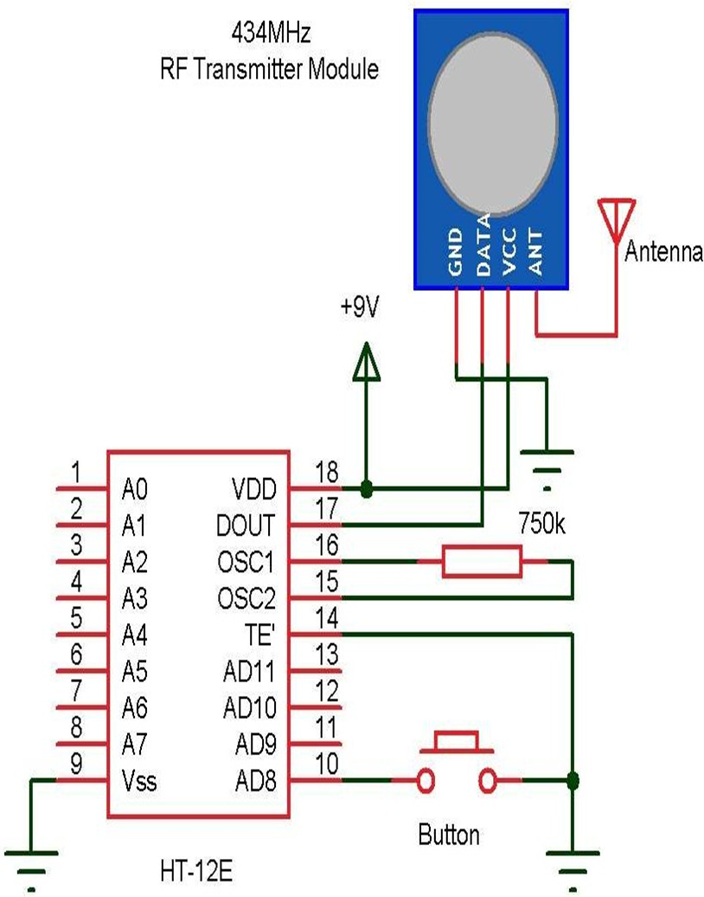

**Figure 1.1 pin diagram**

**CHAPTER 2**

**2.1 ARDUINO UNO**

# The Arduino Uno is an open-source microcontroller board based on the Microchip at mega328P microcontroller and developed by Arduino.cc The board is equipped with sets of digital and Analog input/output (I/O) pins that may be interfaced to various expansion boards (shields) and other circuits. The board has 14 digital I/O pins (six capable of PWM output), 6 Analog I/O pins, and is programmable with the Arduino IDE (Integrated Development Environment), via a type B USB cable. It can be powered by the USB cable or by an external 9-volt battery, though it accepts voltages between 7 and 20 volts. The Uno board is the first in a series of USB-based Arduino boards; it and version 1.0 of the Arduino IDE were the reference versions of Arduino, which have now evolved to newer releases. The ATmega328 on the board comes pre-programmed with a bootloader that allows uploading new code to it without the use of an external hardware programmer. There are many versions of Arduino boards introduced in the market like Arduino Uno, Arduino Due, Arduino Leonardo, Arduino Mega, however, most common versions are Arduino Uno and Arduino Mega.

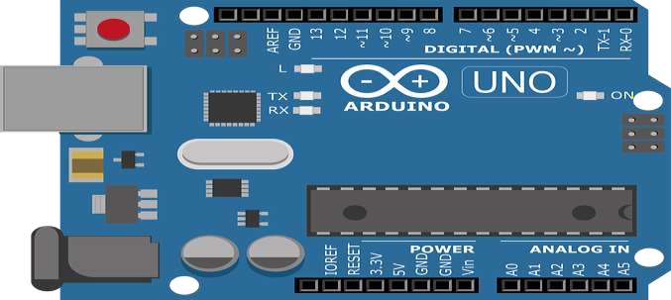**Figure 2.1 Arduino uno**

**2.2 RELAY**

A relay is an electrical switch that opens and closes under the control of another electrical circuit. In the original form, the switch is operated by an electromagnet to open or close one or many sets of contacts. It was invented by Joseph Henry in 1835. Because a relay is able to control an output circuit of higher power than the input circuit, it can be considered to be, in a broad sense, a form of an electrical amplifier.

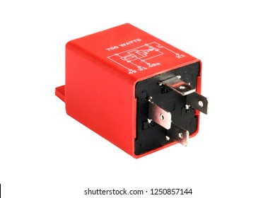

**Figure 2.2 relay**

**2.3 SERVO MOTOR**

A servo motor is a type of motor that can rotate with great precision. Normally this type of motor consists of a control circuit that provides feedback on the current position of the motor shaft, this feedback allows the servo motors to rotate with great precision. If you want to rotate an object at some specific angles or distance, then you use a servo motor. It is just made up of a simple motor which runs through a servo mechanism. If motor is powered by a DC power supply then it is called DC servo motor, and if it is AC-powered motor then it is called AC servo motorA servo motor usually comes with a gear arrangement that allows us to get a very high torque servo motor in small and lightweight packages. Due to these features, they are being used in many applications like toy car, RC helicopters and planes, Robotics, etc.

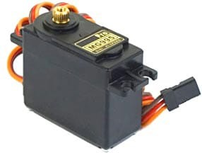

**Figure 2.3 servo motor**

**2.4 RAIN SENSOR**

The **Raindrops module** consists of two boards, namely Rain Board and Control Board.

The **Rain board** module consists of two copper tracks, designed in such a way that under the dry conditions they provide high resistance to the supply voltage, and this output voltage of this module will be 5V. This module’s resistance gradually decreases with respect to an increase in the wetness on the board. As the **resistance decreases, its output voltage also decreases** with respect to the wetness on the module. The **Rain board module** consists of two pins used to connect to the control board.

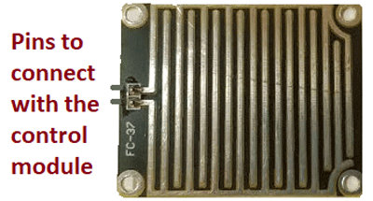

**Figure 2.4 rain drop sensor module**

**The Rain control module**which is shown below consists of 4 pins to connect the Arduino namely VCC, GND, D0, A0 and two more pins to connect the rain board module. In summary, the rain board module detects the rainwater, and the control board module is used to control the sensitivity and compare and convert the analog values to digital values.

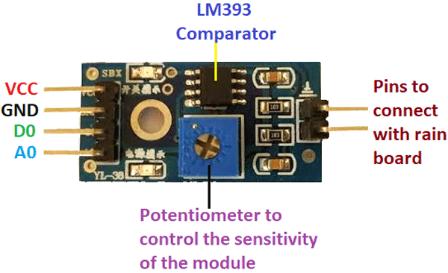

**Figure 2.5 rain sensor**

**BLOCK DIAGRAM**

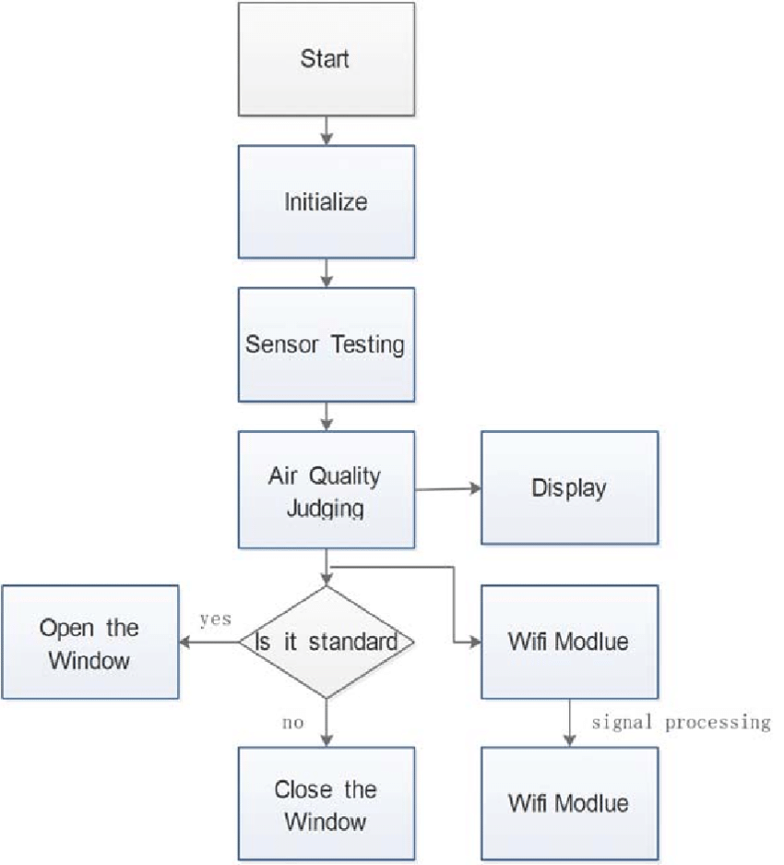

**CHAPTER 3**

**RESULT**

The work is successful and application of such a simple method in a house window seems to be reasonable as unattended open windows can be closed when it rains to protect the indoor from rain. The circuit can further be modified to add a wind speed sensor so as to close the windows when winds of a certain limit of speed blows, thus it will prevent the indoors from unwanted impurities like dust. The circuit and the window structure and mechanism can further be modified for better efficiency and with the consumption of less energy. Another modification is that a battery can be added as a backup power source under no current conditions. The main advantages of automatic window opening and closing system are their low cost and this is having high effectiveness. It requires no special skill to operate and therefore is most suitable for rural application. It can be made from locally available materials.

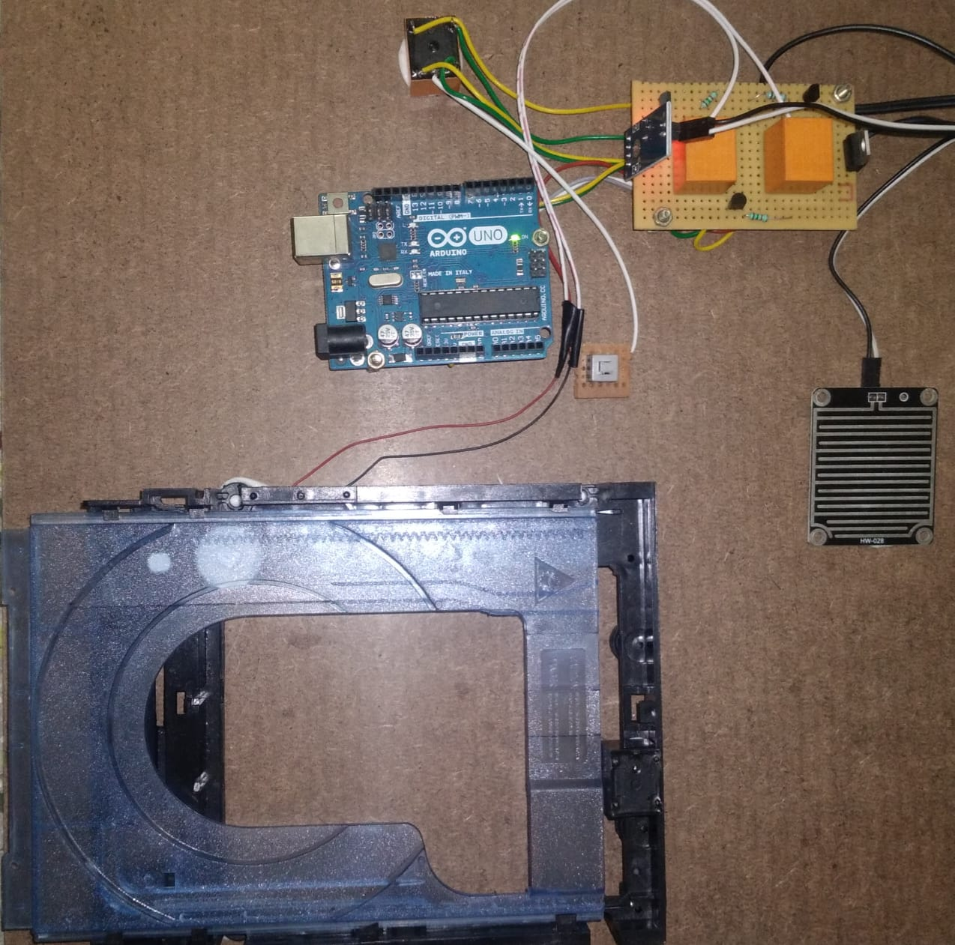

**Figure 3.1 rain drop sensor**

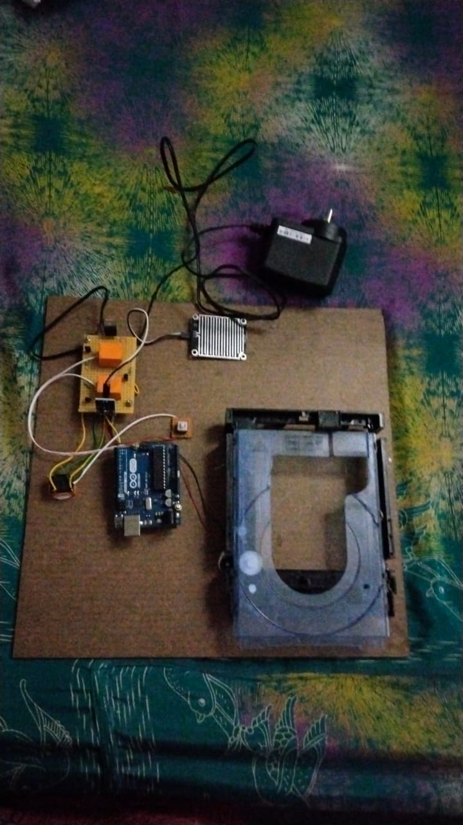

**Figure 3.2 rain drop sensor**

**CHAPTER 4 CONCLUSION**

This paper presents the design and implementation of a simple rain sensor system using Arduino as microcontroller for short range applications. The implemented system detects the rain and automatically closes the window and if there is no rain detected then it automatically opens the windows. Hence, it can be used in houses, hospitals, and in offices etc..., this rain sensor system can be extended and implemented into anything as we wish.

**REFERENCES**

# http://www.bipom.com/minimax51c2.shtm

* <http://forum.icnea.biz/empreses/E6001/ftp/Rj-03(English)>
* http://www.fadisel.com/ing/proamp.aspx?codi=286
* http://www.car-nection.com/yann/Dbas_txt/Drm58.htm
* Mark, J., H.P. Trah Y. Suzuki, 2010.Sensors applications, Sensors for Automotive applications, John wiley& sons, D. Green, 2010. water conservations for small and medium-sized utilities, American water works associatrion.
* ESMA 2018IOP Conf. Series: Earth and Environmental Science 252 (2019) 022010IOP Publishingdoi:10.1088/1755-1315/252/2/0220107 on Intelligent Robots and Systems, 2001. Proceedings. IEEE, 2001: 1584 - 1589 vol.3.
* Zou Y H, Han-Yu L U, Yang Y. Design and Implementation of Intelligent Timing Control System for Household Appliances [J]. Computer Knowledge & Technology, 2018.Dae-Man Han, Jae-Hyun Lim. Smart home energy management system using IEEE 802.15.4 and zigbee[J] . IEEE Transactions on Consumer Electronics.201056 (3): 1403 - 1410.
* Jiang B. Design of intelligent curtain control system for laboratory [J]. Electronic Test, 2018.
* Zhang H, Chen Q, Zhang X, et al. An Intelligent and Tumor-Responsive Fe2+ Donor and Fe2+-Dependent Drugs Cotransport System. [J]. Acs Applied Materials & Interfaces, 2016, 8 (49): 33484.
* Li X, Polytechnic X X. Research on the design of intelligent window control system [J]. Wireless Internet Technology, 2016.
* Sun L. Design and Implementation for Intelligent Dustbin based on 51 Single-Chip Microcomputer [J]. China Computer & Communication, 2017.
* Roundy K A. Systems and methods for detecting information leakage by an organizational insider [J]. 2017.





